EMPLOYEE ANALYSIS DASHBOARD – PROJECT REPORT

1. Introduction
Employee Analysis is an important application of data analysis and Business Intelligence that helps organizations understand their workforce and make better human-resource decisions. The Employee Analytics Dashboard provides a visual analysis of employee information across several dimensions, including:
Dataset Information
Source: Kaggle / **https://www.kaggle.com/datasets/desolution01/messy-employee-dataset
* Department
* Region
* Employee status
* Performance score
* Joining year
* Age
* Salary
* Remote work
* Department and regional salary distribution
* Performance by year
* Employee-level details
The dashboard converts employee data into interactive visualizations and Key Performance Indicators (KPIs), allowing management to quickly identify workforce patterns, performance trends, salary distribution, and employee-related opportunities.
2. Objectives of the Project
The major objectives of the Employee Analytics Dashboard are
1. To analyse the overall employee population.
2. To identify the number of active, pending, and inactive employees.
3. To understand employee distribution across departments.
4. To analyse employee distribution across different regions.
5. To evaluate employee performance scores.
6. To analyse salary distribution by department and region.
7. To understand employee age distribution.
8. To analyse remote-work participation.
9. To identify employee joining trends over the years.
10. To compare performance across different years.
11. To provide detailed employee-level information for further analysis.
12. To support data-driven HR and workforce management decisions.
3. Dashboard Overview
The dashboard includes multiple filters that let users interact with the data.
Main Filters
The available filters include:
* Department
* Region
* Status
* Performance Score
* Join Year
* Remote Work
These filters allow management to examine specific groups of employees instead of analyzing the entire workforce at once.
For example, management can select a particular department and region to understand employee performance, salary, and status within that specific group.
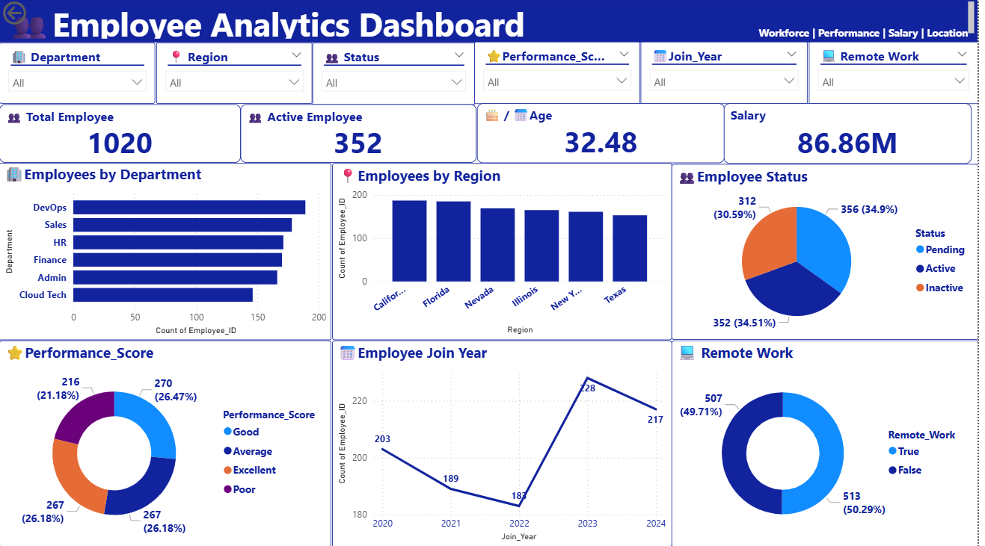

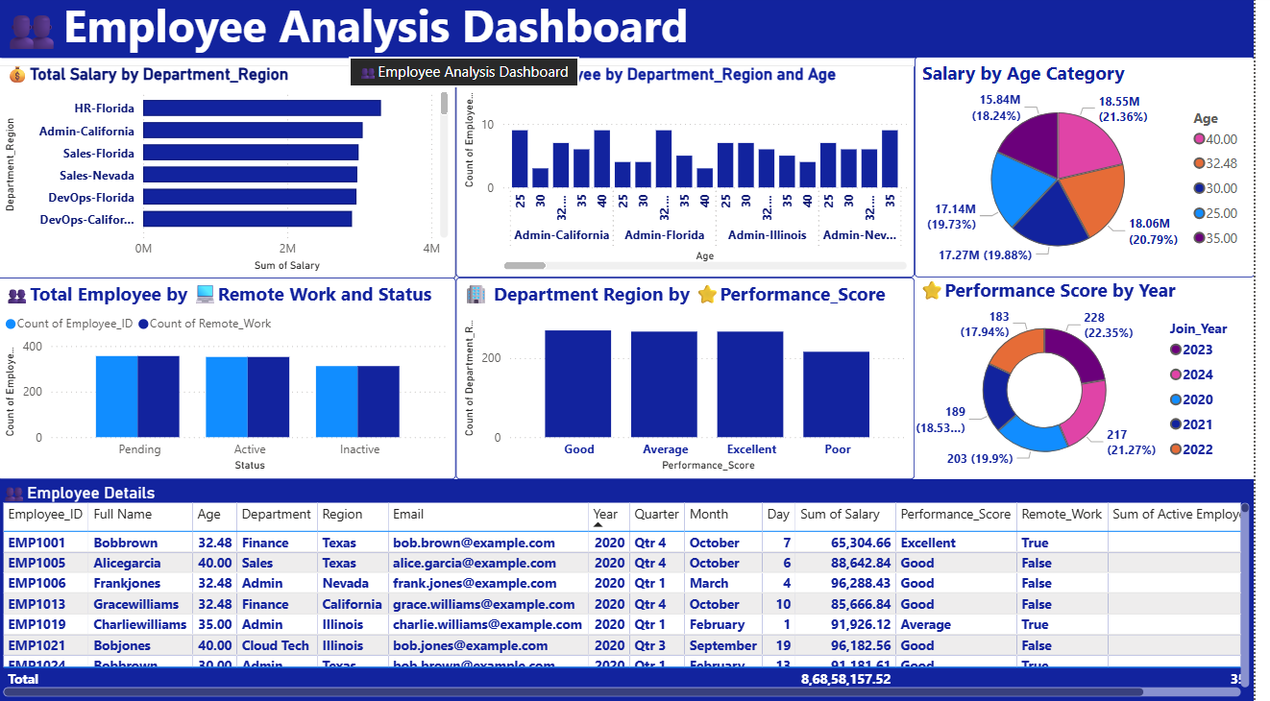

4. Key Performance Indicators
The first dashboard presents four major KPIs.
Total Employees 1,020
Active Employees 352
Average Age 32.48 years
Total Salary 86.86M
Total Employees
The organisation has a total workforce of 1,020 employees.
This provides the overall population for the remaining employee analytics.
Active Employees
There are 352 active employees, representing approximately 34.5% of the total workforce. This indicates that employee status is an important area for HR analysis because a significant portion of the workforce falls into other status categories.
Average Age
The average employee age is 32.48 years.This suggests the workforce is relatively young and may include many employees in the early and middle stages of their careers.

Total Salary
The total salary represented in the dashboard is approximately 86.86M. Salary is one of the largest employee-related organisational expenses, making salary analysis important for budgeting, compensation planning, and identifying differences across departments and regions
5. Employees by Department
The dashboard provides a comparison of employee counts across departments.The major departments shown are:
* DevOps
* Sales
* HR
* Finance
* Admin
* Cloud Tech
Analysis
DevOps has the highest employee count among the departments displayed.
Sales and HR also have relatively large employee populations, followed by Finance and Admin. Cloud Tech has the lowest employee count among the departments shown.
6. Employees by Region
The dashboard analyzes employee distribution across regions including:
* California
* Florida
* Nevada
* Illinois
* New York
* Texas
California and Florida show relatively high employee counts, while Texas has the lowest count among the displayed regions.

7. Employee Status Analysis
The employee-status chart divides the workforce into:
* Pending
* Active
* Inactive
The dashboard shows:
* Pending: 356 employees — approximately 34.9%
* Active: 352 employees — approximately 34.5%
* Inactive: 312 employees — approximately 30.6%
Interpretation
The relatively balanced distribution between the three categories is an important finding.
The organisation should investigate why a significant number of employees are classified as inactive or pending.
8. Performance Score Analysis
Employee performance is classified into four categories:
* Good
* Average
* Excellent
* Poor
Performance Employees Percentage
Good 270 26.47%
Average 267 26.18%
Excellent 267 26.18%
Poor 216 21.18%
Interpretation
The Good, Average, and Excellent categories have relatively similar employee counts.
However, approximately 21% of employees fall into the Poor performance category.

9. Employee Join-Year Analysis
The dashboard analyses employee joining trends from 2020 to 2024.
The displayed employee counts are approximately:
Join Year Employees
2020 203
2021 189
2022 183
2023 228
2024 217
Interpretation
Employee joining numbers decreased from 2020 through 2022.
The organisation then experienced a significant increase in hiring in 2023, reaching approximately 228 employees.
Hiring remained relatively strong in 2024 with approximately 217 employees.
This may indicate an expansion in workforce requirements during 2023–2024.
10. Remote Work Analysis
The Remote Work dashboard shows:
* True: 513 employees — 50.29%
* False: 507 employees — 49.71%
Interpretation
Remote and non-remote employees are almost equally distributed.
This indicates a relatively balanced working model between remote and non-remote employees.
The organisation can use this information to evaluate:
Further analysis can compare Remote Work vs. Performance Score to determine whether working location has any relationship with employee performance.

11. Salary by Age Category
The second dashboard analyses salary distribution by age category.
The displayed salary groups include approximately:
* 40.00
* 32.48
* 30.00
* 25.00
* 35.00
The salary distribution is relatively spread across these age categories.
Salary-by-age analysis can help HR understand whether compensation increases with employee age or career progression.
12. Total Salary by Department and Region
The dashboard provides a combined Department + Region salary analysis.
Examples include:
* HR – Florida
* Admin – California
* Sales – Florida
* Sales – Nevada
* DevOps – Florida
* DevOps – California
13. Employees by Department, Region and Age
The dashboard provides a detailed comparison of employee counts according to:
Department → Region → Age
This provides a more granular view of workforce composition.
For example, management can determine how many employees of particular age groups are working in specific department-region combinations.
This type of analysis can support:
14. Employee Status and Remote Work
The dashboard compares employee status with remote-work information.
The analysis provides an opportunity to determine whether:
* Active employees are more likely to work remotely.
* Pending employees have higher or lower remote-work participation.
* Inactive employees are predominantly remote or non-remote.
This can be particularly useful when developing hybrid and remote-work policies.
15. Department Region by Performance Score
The dashboard compares employee counts across:
* Good
* Average
* Excellent
* Poor
This helps management determine whether certain department-region combinations have stronger or weaker performance.
The Good, Average, and Excellent categories have relatively strong employee counts, while the Poor category is lower but still significant.
The organisation should investigate the causes of lower performance and develop targeted improvement programs.
16. Performance Score by Year
The dashboard also analyzes performance scores across joining years.
This allows management to investigate whether employee performance varies depending on the year employees joined the organization.
For example, HR can determine whether newer employees require more training or whether experienced employees demonstrate consistently higher performance.
20. Conclusion
The Employee Analytics Dashboard provides a comprehensive view of the organization’s workforce and enables management to understand employee distribution, performance, salary, location, joining trends, and remote-work patterns.
With 1,020 employees, 352 active employees, an average age of 32.48 years, and approximately 86.86M in total salary, the dashboard provides valuable information for strategic workforce management.
The analysis shows that the workforce is distributed across multiple departments and regions, while remote and non-remote employees are almost evenly divided. Performance analysis
Overall, the dashboard can help HR and management make data-driven decisions regarding recruitment, retention, compensation, employee development, performance management, workforce planning, and remote-work strategy.

